E) Find the list of Active Airlines in United state

select * from final_airlines where territory like '%United States%' AND active like '%Y%';

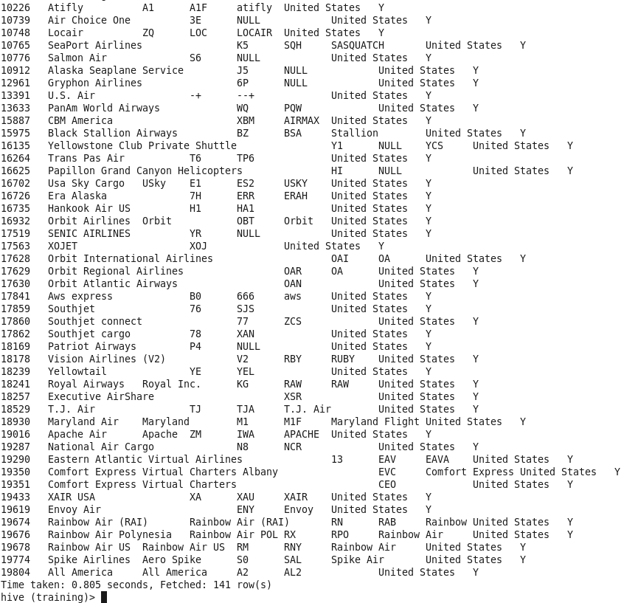

F)find top 10 countries with highest number of airports.

Select airport_country,count(airport_id) as airport_count from airport group by airport_country order by airport_count desc limit 10;

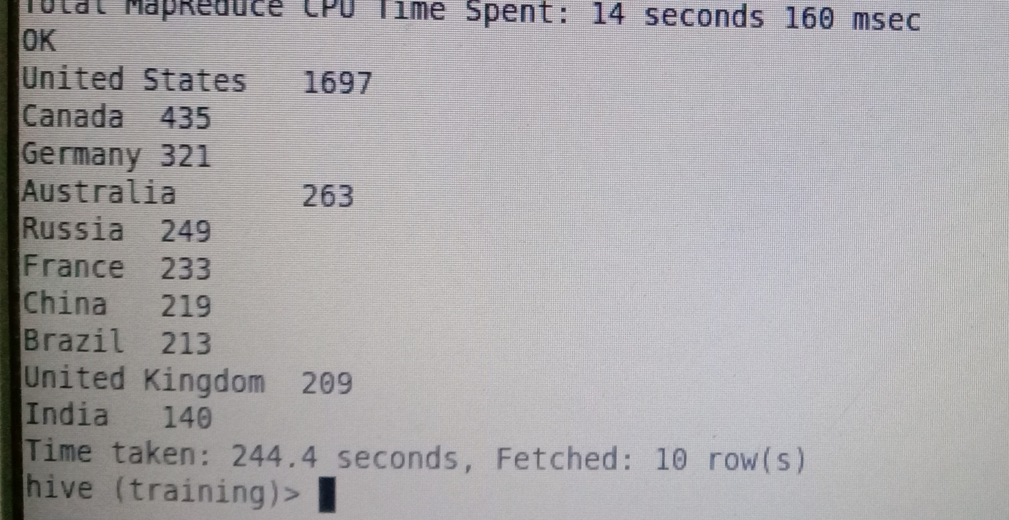

G)find the airport at the highest altitude.

Select a.airport_name from airport as a where a.airport_alt in (select max(b.airport_alt) from airport as b);

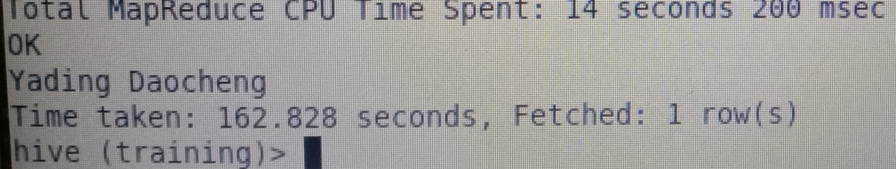

H)find number of airports both in east and west zone.

Select count(case when airport_timezone<0 then airport_id end) as West,count(case when airport_timezone>0 then airport_id end) as East, count(case when airport_timezone=0 then airport_id end) as Neutral) from airport;

